Day 1: Introduction to 5 Critical Tools to Reclaim and Maintain Your Inner Peace
I recommend taking a day or two with each lesson and tool. Please NO pressure - this about peace and calm remember? :)
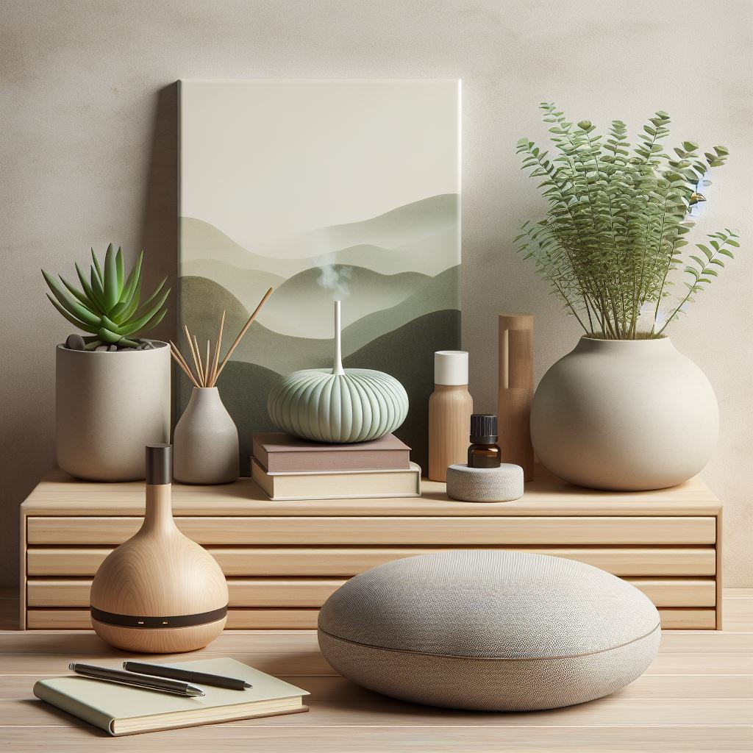
Inner Peace IS possible no matter what is going on in the outside world. YES, LIFE WILL happen. I can guarantee there will be challenges. These days you may feel with the world looking a little crazy it might feel impossible. But if you have your inner compass set to PEACE you will return there.
Thank you for joining me on this journey. Included in this ebook is 5 more days of tools and information to practice to make this inner peace your reality.

I am beginning with an introduction and a commitment I want you to make for yourself to use these tools. The more you practice the tools I am offering - the easier life will become. Even when challenges appear - you will be able to process and learn from the experience, and regain a state of grace and flow.
You will NOTICE the challenges, but they will become fewer and further between AND last a MUCH shorter time.
Thank YOU for taking this journey with me. My life looked COMPLETELY different 20 years ago. I am unrecognizable to myself. I am a recovering perfectionist and people pleaser. My behaviors and relationships reflected that. I have now moved into an unapologetically authentic version of myself. I have the relationship, career and friendships of my dreams and am working right now on relocating to the place of my dreams. It IS possible to have it all when inner peace is achieved!!

Discovering who we truly are without our traumas and triggers brings such deep peace, flow and clarity.

We ALL deserve to have peace. We cannot help anyone, including ourselves if we feel completely disempowered. When we bring ourselves to peace - there IS a ripple effect in our loved ones, and the world around us.

There are key things I wanted to outline before you get started to begin to remove the resistance you may be feeling at attaining inner peace.

- Give yourself permission. The world outside can seem so daunting and honestly anxiety and depression inducing - depending on where you focus. You may even feel, "Who Am I to feel happy when there is so much pain in the world?” You cannot help ANYONE from a state of despair, anxiety and distraction. YOU finding inner peace can HELP others from a state of love. Please take this time right now and give yourself permission to attain inner peace.
- Thoughts create energy. We all have over 60,000 thoughts a day. Usually 90% are the same as yesterday and 80% are negative. I changed from being told I would be in a wheelchair and 7 years of chronic illness by changing my thoughts.. which changed my emotions.. which created NEW energy and new mental pathways. It IS possible!!!
- Using LITTLE windows of time we can slowly work to switch our thoughts up - which ensures change. The MOST powerful times to do this work are RIGHT when you wake up, BEFORE Bed when your subconscious is tuned in. AND I also love the shower as a meditation time as it is a time we all have of quiet. You can also do most of these exercises while doing some “unconscious” tasks - when doing laundry, doing dishes, brushing teeth, etc. Know this does not take hours of time.. but it does take a gentle bringing yourself back to the present moment.
- The present moment and a plan - Decide and commit to HOW you will be doing this work. Will you try a few different ways and see which fits? Maybe you will alternate and PLAY? THAT is totally fine!! Set an alarm on your clock for a few times a day to ask yourself where your mind has been. Decide the shower time is your meditation time. There will be a few writing exercises to get you started but MOST of the exercises I will offer CAN be done anywhere.
- Have fun and be compassionate with yourself! Be gentle and kind with yourself as you move forward. There will be times you go a little sideways and backward… noticing IS power. Noticing how easy these tools really are and having FUN with them - makes the process easier. Noticing life is getting easier and giving gratitude you ware working toward this at all BECAUSE you love yourself and WANT life to be peaceful - helps a LOT!!!
- For today…. Make this commitment, think about times you can do some of this work, and commit to having fun.
- Breathe - if all else fails and you feel anxious - BREATHE. My favorite breath work technique is Box Breathing given to Navy seals - Box Breathing is breathing in for a count of 4, holding for a count of 4, exhaling for a count of 4, and holding for a count of 4. Do this 3 times and you WILL feel stress melt away. If this is uncomfy, simply NOTICE your breath going in and out and intend it to slow. Our breath connects us with the current moment and offers us PEACE when we slow down!
Tomorrow, if you feel ready, please read and receive the first two tools included in the first lesson. It is THE MOST powerful practice of all to attain inner peace…and the one most important to my physical healing… gratitude!



DAY 1 - Gratitude

I know, you can be thinking, “Hmm, gratitude - what can THAT do? - or “I AM grateful”. Expressing gratitude, DEEPLY, where you FEEL it in your body is truly transformative.

When I was healing physically I switched my focus from how badly my body felt to how grateful I was I had a comfy bed, had a finger that didn’t hurt, could read to my kids even if I couldn’t run after them, etc. Gratitude is LOVE and Appreciation and changes our brain and body chemistry.

Gratitude is two fold. It is important to be grateful for the things that ARE right in our lives (this can be as small as a meal, toothbrush, shower, running water, etc). BUT it is even more important to pay gratitude for yourself. We often are our harshest critic and that does NOT do us any good. We would usually never talk to a loved one or a pet the way we speak to ourselves… you deserve to give yourself gratitude for all you have been through and for being here right now. YOU are reading this because you want to feel better and want to feel peace - THAT is a reason to be grateful. You care enough about yourself to WANT to invite that in. Congratulations!!!!

There are two exercises I will offer here and I want you to do BOTH!! Again, you can do these in the shower, before bed or RIGHT when you wake up. You can even choose to do these as you are doing household tasks or things where your brain is usually running… but the first few times you do these, it would be wonderful if you could do these and put ALL your attention on gratitude. The MORE you bring your attention to the present moment and practice gratitude -the faster you will FEEL shifts in your life.

Exercise 1: Take some slow breaths and intend to GET PRESENT. If you are NOT multi-tasking - bring your hands to your heart. Bring your attention to something in yourself you are grateful for. Maybe you love to love. Perhaps you are great with animals, love cooking, look after friends and family, love and appreciate nature, love to laugh or are creative. There are qualities you have that YOU have that are beautiful and deserve to be honored. I want you to imagine this quality in yourself and say “thank you” to yourself for having this quality. Breathe that gratitude and thanks into your heart and exhale out any resistance you feel giving yourself this credit. Repeat. You can do this with one quality, behavior or action you do - or contemplate a few different ones. Every time, breathing them into your heart and exhaling out any resistance you have to giving yourself this credit. When you give gratitude for yourself you are activating empowerment and self love. This is critical for inner peace.
Exercise 2: Take some slow breaths and intend to be present. Bring to mind something you are grateful for… it could be a pet, a loved one (even someone who has passed), a spot in nature, a comfy bed. ONE thing that you are very grateful for. Bring in every sense - what does it FEEL like, look like, are smells and tastes and sounds involved? FEEL this gratitude and breathe that sense of gratitude into your heart, exhale out any resistance you have for bringing up this feeling. Repeat with one thing, person, event for a few minutes. If guided you can repeat with a new event after the first one feels complete.
Optional Exercise: Write a gratitude list. Each night, my husband and I write down things we are grateful for that day and what we are looking forward to the next day. It is a beautiful way to take stock of all that is going right and what there is to look forward to!! You can do this any time of day and it can take a couple of minutes… but it truly helps shift energy!!

ANY time you spend doing these exercises - even if for a few minutes - will change your chemistry and invite in inner peace. The MORE times you do it - the better you will feel faster… but this is not a race… This is about moving at a pace that feels comfortable for YOU.

Give yourself credit ANY time you take time for these exercises. If you forget, be compassionate with yourself and make a plan for doing these soon. Gratitude was my MOST important tool in healing and is a GO TO. It melts away stress and affirms to the Universe ARE ALWAYS things always to be grateful for.

Sending much love your way. Below is a poem that might help you imbue gratitude further… Please give yourself a couple of days to practice this and when you are ready, dive into Day 2…. 10 Things that Bring you Joy and Peace.

Gratitude 2

Gratitude is the seed
That helps our joy to grow
It plants love and appreciation
Connecting us to flow.

People tend to focus
On negativity and what is wrong
But that feeds disempowerment, weakness
Instead of feeling empowered and strong.

In a world that is rapidly changing
It can feel we have little control over our mind
So much distraction and news
Gratitude can feel hard to find.

But we all have things to be grateful for
We woke up today and get to breathe air
We have compassion in our hearts
People, animals and causes for which we care.

We might feel guilty feeling grateful
Witnessing what so many have to endure
But by focusing on gratitude
We add to being the love and the cure.

Start with the small things
When you get out of bed
Embrace being mindful
At the thoughts in your head.

Are you paying attention
To the little gifts that surround you?
Have you given yourself credit
For all you have made it through?
Even a few moments of gratitude
Can water that seed
You get to choose to limit it
Or help it feed.

When that sprout begins to grow
You truly notice life’s changes
Your day begins to feel easier
With less extreme mood ranges.

When it breaks through the ground
Your appreciative thoughts give it sun
Life will hand you blessings
And you will start to have more fun.

It doesn’t take hours to pay gratitude
You have every second to make that choice
A few moments here and there
Truly give your life a new voice.

When you are leading with gratitude
Blessings truly abound
Then you have more to offer others
Feels a new lease on life has been found.

As the stem grows and the bud forms
Gratitude becomes a routine
You’ve witnessed things shifting
Feel more heard and seen.

When you’ve made gratitude a daily habit
the flower is in bloom
You notice how much lighter you feel
How your heart seems to have much more room.

What a beautiful world it would be
If we all paid gratitude often
We would connect in oneness and love
ALL of our hearts would soften.

It begins with you today
take a few moments to go within
I promise soon after
You’ll feel your heart and soul grin.


Day 2 - 10 Things that Bring you Joy and Peace

We often go through our day as task masters and then, repeat. We often do NOT make time for things that truly bring us JOY, saying we are “too busy”. Doing things DAILY that bring you to a state of joy or peace - affirms to the Universe 1) I am worthy of joy and peace 2) Life IS fun after all 3) I am grateful to be alive.

Writing a list of 10 things that bring you joy and peace is essential in maintaining peace. We as humans, are self-sabotaging. If we have this list of 10 things we are noticing and affirming there are 10 things we love and we can go to daily. These things do not have to take long periods of time. This can be singing or dancing around the living room to a favorite song, having a cup of tea and relaxing, cuddling with a pet, taking a walk in nature or some breaths outside, reading, writing, doodling, coloring, calling an old friend that makes you laugh, meditate, do breathing exercises, etc. These are things that when you think of you feel warm and fuzzy inside. They bring that sense of, “Ahhhhhhh, this feels GOOOOD”. It could be a bath, a self massage, 5-10 minutes of watching funny cat/dog videos, doing some stretches or Tai Chi/Qi Gong, learning something new like a language app, etc. Only YOU know what brings you to a state of joy and peace.

Why 10 things? Wellll, we are human… sometimes we will look at the list, arms crossed like a stubborn child and be like, “But, I don’t feeeeeeel like doing that!” If you have a list of 10 thing - there will be 1 that resonates at all times!! Pick the 1!

Exercise: Write a list of 10 things that bring you joy and/or peace. Keep this list somewhere where you see it. Make a commitment to yourself to do ONE of these items DAILY!!! Even if for 5 minutes. If possible, note or write down how you FEEL after each activity. You can also express gratitude for yourself, even if it a simple “thank you” does wonders!!!

Please take some time to do this and COMMIT to doing one of these. See how it goes and then come back to Day 3…. Forgiveness; which is critical on inviting in inner peace. .

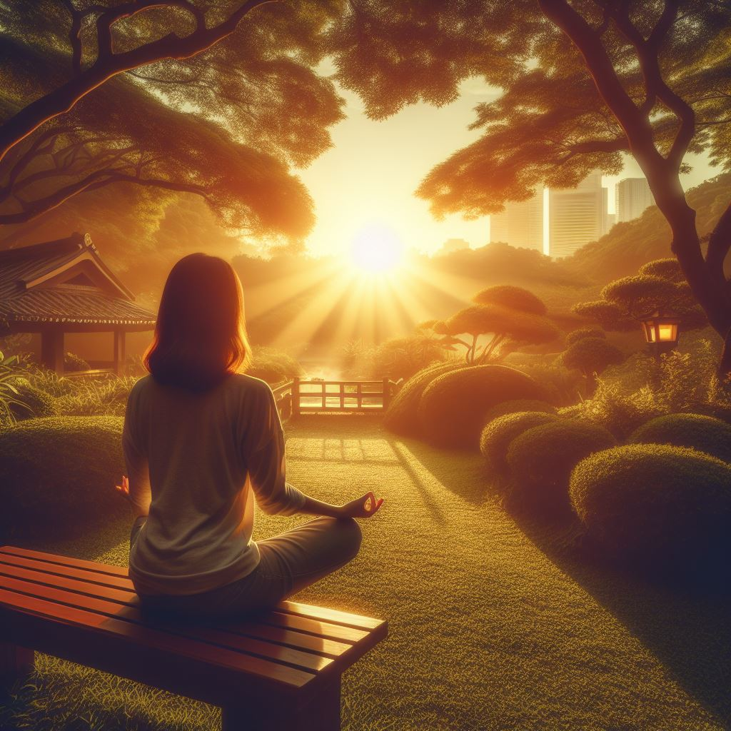

Day 3 - Forgiveness

Even this word can spark some triggers, so please be gentle with yourself as you read this. Blame, shame and guilt are pretty low vibe emotions and bring the OPPOSITE of peace. Forgiveness doesn’t mean we are totally fine and happy about what occurred. It DOES mean we have spent enough time, energy, worry, on that event and are ready to free OURSELVES to move forward. By holding onto blame, shame or guilt we are literally tethering ourselves to an unhealthy and unhappy existence. We cannot fully move into inner peace without doing some kind of forgiveness work for others and for ourselves.

It is important to note hurt people hurt people. If you have been hurt by another - they were not a happy healthy person. If YOU reacted and hurt someone else - you were reacting from a hurt place. This all deserve some kind of compassion. If you do not heal your wounds - you WILL hurt others. If people have hurt you - maybe they felt it was impossible to heal or it never even entered their state of consciousness. No, it does not EXCUSE the scar it left but it can give us an understanding of the WHY and also permission to let it go. Giving the situation more energy gives that person continued power over us.
Of course if there is real trauma - sometimes we need to get counseling, go through some kind of deeper processes. But forgiveness is KEY to moving forward.

When I was 9, I was sexually abused by a family friend. It was also a time I was very vulnerable as my parents were divorcing. This caused all kinds of self loathing and behaviors that reflected that. It was decades before I realized the impact it had on my life. Compounded by that, was when I told my therapist she said, “it is so common it doesn’t really matter”. Yes, that was probably because she was abused too - but I did not recognize it at the time. I took it as, “get over it - it’s no big deal” and did NOT process nor heal it until years later. My abuser was also sexually abused - by his own father. Hurt people hurt people. He had not healed these wounds - so he inflicted them on me.

I say this to let you know, really shitty things happen to people all the time. I have heard of atrocities that have made my skin crawl in my 20 years of seeing clients. Things that should NOT happen to people - do. But if we stay in that wounded space - we are hurting ourselves. If we let these situations define us - we limit ourselves from our potential and the beauty and peace in life. I have learned a LOT of different forgiveness and release rituals in my studies - following are 2 of my favorites. YOU DO what resonates with you.

Exercise 1: Ho’oponopono - This is taken directly from Chapter 1 of my book, “A Short Path to Change: 30 Ways to Transform Your Life”.

Ho’oponopono
When I heard the case of Dr. Len using Ho’oponopono to release and heal most clients of a criminal psychiatric hospital, without even seeing them, I knew I had to know more. Dr. Len was a psychiatrist at a notoriously harsh criminal mental institution in Hawaii. Instead of seeing the clients for normal counseling sessions, he sat with their file for the allotted session time and said the Ho’oponopono prayer for them. Within a few months, people noticed a difference and patients were being taken off of their medications. Violence was down, plants were growing on the grounds where they never could before, and the whole attitude of the place had changed. Within a few years, many of the patients were released. He had healed a huge percentage of the people in the hospital without even meeting with them!
Ho’oponopono is based on the fact that we are all connected and that we are 100 percent responsible for the reality we create. As Dr. Len puts it, “have you ever noticed that when you perceive of a problem you feel like you are there?” Accepting that it is your responsibility does not mean it is your fault. It means that you are responsible for healing yourself in order to heal whoever or whatever appears to be your problem.
This prayer works by truly talking to our soul and the souls of others. We are all connected at soul level. At soul level, there are no limits and we know we can always forgive and that we are responsible for what we create and for how we perceive reality. We are limitless; we can heal, and we are always capable of love. We can examine the negative feelings we have held so tightly and know we are strong enough at soul level to heal them. The Ho’oponopono prayer consists of four simple sentences, and I highly recommend you begin by using it for some self-healing and forgiveness. If you are like most people, you are often sway too hard on yourself! However, if you were able to truly understand how perfect you are and that everything is a learning experience, you would always treat yourself with the same kindness you show your closest loved ones.
I recommend taking at least a few minutes to say this prayer though even in saying it a few times, you will feel its power. Take a second to center yourself and to become aware of your surroundings. Notice your breath. Become present and repeat the following 4 sentences. As you do, I ask you to recognize that your human aspect is speaking directly to your soul.
- I love you.
- I am sorry.
- Please forgive me.
- Thank you.
By saying this, you are affirming your love for your soul. You are apologizing for letting your mind and this third dimensional world get the best of you and for carrying you into a state of unhappiness when, in reality all is truly perfect. You are asking for forgiveness because you know you want to be truly connected and are sorry you put your soul through this, but you also acknowledge that it is challenging to be human sometimes. You are realizing you are responsible for these thoughts and emotions. You are grateful and pay this debt of gratitude by saying thank you for this love and forgiveness that is always present and available to you.
It can be very emotional and powerful saying these few sentences; feel them when you say them. This works whether you say it out aloud or silently. Although I have found that the times I have allowed myself to utter these words out loud even more profoundly powerful.
If you do this for even a few minutes each day, for yourself, you will see a profound change in your life. If you do this for another person, look at it in the same manner. Your soul is reaching out and forgiving their soul. Most times, when we are hurt, it was not an intentional act on the part of the offending individual. That person is simply reacting and acting from what they know and their own state of consciousness. They have not intentionally gone out of their way to hurt you because of anything you are or have done. If you find it hard to forgive someone and let go of the pain on the third dimensional level, try this exercise and see what happens.
A few years ago, I was working on a project and had someone assigned to help me from a company I needed to collaborate with. This man was not very professional. Even though we had 9:00AM meetings, he would frequently show up reeking of alcohol. He also smelled like shampoo and his breath didn't smell, so I didn’t get the feeling he was drinking in the morning. I believe he drank so much the night before (and probably most nights), that it was literally seeping through his skin. There were many delays in him meeting with my team. When he finally did show up from another state, he had one simple task - bring the piece we needed for the project. One morning, I arrived at the meeting place to see him outside with his car doors and trunk open and a mess all over; he appeared very distraught. He had made these plans a month in advance, traveled four hours to meet with us and had forgotten the only one thing he had to bring. Needless to say, I was not happy. I tried to hide my disappointment and kept thinking that if this man was drinking so much that he reeked of alcohol 24/7, he probably was not a very happy person. Instead of cursing him or complaining about him endlessly and adding to that negative energy, I decided I would try doing “Ho’oponopono” for him. Within 48 hours, he was switched off of my project. This is a small example. I have had several in my own life and have had clients tell me repeatedly about the miracles Ho’oponopono has brought into their lives.

Learning to Forgive Yourself and Others with Ho'oponopono
Find a quiet space. Allow yourself ten minutes for this exercise and five minutes after. Take some long slow breaths and notice them... do not judge your breath, just notice and become aware of it and let the in and out of your breath bring you to this present moment.
For the first five minutes, I would like you to say these sentences of Ho’oponopono out loud (if possible) or to yourself (Your human self is saying them to your inner self - your soul):

- I love you.
- I am sorry.
- Please forgive me.
- Thank you.

Notice how you feel as you say them. Mean them, feel them! For the second five minutes, I would like you to say this directed at a person in your life. It can be someone who you feel needs healing. It can also be someone who you have had a challenging time with. Understand, as Dr. Deepak Chopra says, “Everyone is doing the best they can from their own state of consciousness”. You are not excusing anything that has been done but are connecting with that person at soul level and moving beyond the illusion that we truly know all the factors in a given situation. You are taking into consideration that you too have been adding to the energy of that person being a challenging person or wrong in a situation by replaying that to the Universe every time you think about them. When you are saying sorry you are saying you are sorry for contributing to that energy and also know that person has their own challenges. You are looking beyond what that person might have shown in this third dimensional life and you are looking to their soul, who is also perfect as yours is. Say the prayer for this person for five minutes, feeling it and noticing how you feel:

- I love you.
- I am sorry.
- Please forgive me.
- Thank you.

For the last five minutes, I would like you to write in your journal or to sit and reflect about how you felt saying Ho’oponopono each time. Was saying it for yourself and then for the other person a different experience?
The beauty of Ho’oponopono is its simplicity. You can say this in the shower, before bed, in the morning - silently or out loud. You will see a difference in how you feel the more you say this prayer.

Exercise 2 - Burn stuff! - LOL. Okay yeah I am a Leo, love fire and burning stuff - feels sooooo freeing!! PLEASE exercise CAUTION when doing ANY burning exercises and stay put into the fire is safely OUT.
You can do this a few different ways. You can:
1. Write a letter saying how this person or event hurt you and burn it. As you burn the list give thanks you are freeing yourself.
2. You can write down the names of all people that hurt you and you are ready to release energy from. As you burn the list give thanks you are freeing yourself.
3. You can get little twigs and blow the names or events into the twigs as you think of them, then burn them.
4. If possible do a little celebration afterward or as these things burn - play a favorite upbeat song, dance if possible. Give thanks for the freedom you are giving yourself for releasing this energy!!!

Please take a couple of days to do these exercises - Ho’oponopono can be done ANYWHERE and is my go-to if I wake up in the middle of the night and have trouble getting back to sleep. Remember to PLAY and to be gentle with yourself This work is to bring you PEACE. You may feel lots of emotion come up - be gentle, compassionate and loving with yourself as they do. You most likely have held onto this energy for a long time. You might face resistance in letting it go. But in letting go, you make room for inner peace… and THAT is priceless. Tears may come up - tears ARE release… let those tears flow.. they are clearing the way for new fresh, peaceful energy to come in!
Next we will be diving into moving forward… List Making - to Claim what you want!!



Day 4: List Making - Claiming What you WANT
If you go back to day 1 - you will remember me stating the fact we have over 60,000 thoughts a day, 90% the same as yesterday and 80% negative. If you ever tune into “the news” the worst possible story is FIRST and most prominent. Us humans are PROGRAMMED to think negatively. This course has been about REPROGRAMMING Your Mind for Inner Peace.

If you ask most people what they want, they might respond, “to be happy.” If you ask them to expand on what would MAKE them happy they might pause. We send so many mixed thoughts out to the Universe and usually if we think about what we want, it comes from a fear-based space and not from love. “I want to be out of debt”, “I am so lonely I want someone to love me”, “I want out of this job that sucks” etc. That energy does not usually help in bringing to life what WE DO desire.

If you’ve followed me, you know I manifested the love of my life with a “He is” list. We’ve been together almost 11 years and it keeps getting better and better - and started off pretty damn amazing! My hsusband and I got married last year and we also manifested the home we live in now by writing a list. We are now working on that new one we will relocate to. I KNOW the power of lists firsthand and have seen them create MUCh success in my clients.

Guidelines for lists
- Only write them in the positive of what you want - not the negative. For example.. on my “He IS” list.. (which was 2 pages single spaced by the way) LOL I wrote He is kind, he is good with my kids, he is loving, he is funny, he has a good sense of humor, he is honest, etc.. I did NOT write, “he is not a jerk.” You want your list to be positive, as you want that energy going toward what you are asking to bring in.
- DO NOT settle or write a list you feel limits you. This is about you manifesting what you deserve and want which will bring you peace. This is NOT about playing small. GO FOR IT. If you are writing a list about a career - say, “My career allows me to work “x” number of hours”, claim, “My career allows me to make “x” amount of dollars, etc. These lists are also a testament to our self worth. What are you ready to embrace to bring more peace into your world??? The BEST advice I got after my husband and I had split and I was starting to date, was, “DO NOT SETTLE”. So many times we can make excuses, think we HAVE to settle. But settling does NOT bring peace. It brings us doubt, a lack of self worth, a feeling that life isn’t fair, and resentment. THAT is NOT peaceful!
- Store your list a place where you can work on it. I like having my lists in a document on the computer so I can edit it. Plus boy my handwriting is pretty atrocious! LOL As you work on it - new awareness and words will come to you. My “He is” lost evolved over years and I feel my love did not walk in until my list was perfect for me and I was ready. When I moved out from living with my husband I manifested a placed to live in 4 days… It really depends on what you are asking for and also knowing and trusting in Divine Timing.

Exercise: Decide what will bring you inner peace and what your first list will be on. Is it a relationship, career, friends, a new home that you are calling to you? Follow the above instructions and begin to create that list. IF you do not have a particular thing you are inviting in.. think about the aspects of your life; spiritual, emotional, mental, physical, relationships, financial and if there is anything you want to change or in - in your life and write about that.
Read your list and FEEL it as if it has happened. Get excited about this person, this career, this home coming into your life. What kind of emotions does this evoke? Make a commitment to look at this list.. if it is something you want soon - then look at it every day.. if it us something you are calling in but have time for.. make a commitment to look at this every few days or once/week… edit as it calls to you to edit. THANK YOURSELF for taking this time.

Please take a couple of days with this list. Also put it somewhere - where toy an add to it - as things WILL come up. The final lesson on how to create and sustain inner peace is , “Continued time for Mindfulness.”

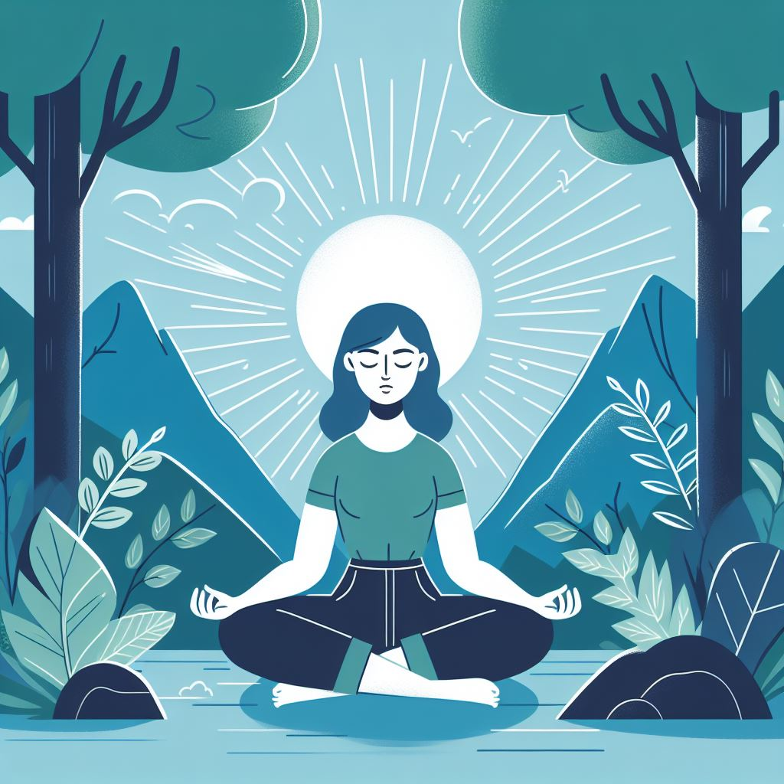

Day 5: Continued Time for Mindfulness

“A journey of a thousand miles begins with a single step” - Chinese Proverb

If you have made it this far - congratulations!!! You have taken several steps and are well on your way to reclaiming and maintaining inner peace!

Then journey continues and you are now equipped with some powerful tools. Today I will remind you of the ones you learned and offer a few more to keep moving forward.

What you have learned so far:

- Windows of times to do this work
- The Importance of Your thoughts
- Breath-work (Box Breathing)
- Gratitude for yourself and others
- Doing things that bring you joy/peace daily
- Forgiveness for yourself and others
- The importance of list making/Claiming what you want

These are some important things to remember as you move forward:

- Life is NOT a straightforward journey - There will be times you are challenged, triggered and face adversity. YOU have the choice in each moment HOW to respond. It is important to recognize and process emotions. It is also important to offer yourself deep compassion on your journey and encourage yourself to move forward.
- Remember your tools - Not all tools fit every moment - you pick which tools resonate and be gentle with yourself if you fall in and out of practice. NOTICE how much better you feel if you do use these easy tools. Give yourself thanks ANY and all times you remember to use them
- Self Love/Self Worth - KNOW you deserve happiness. No matter what has happened previously in life.. no matter what has happened to you, you have experienced, or you feel you have done “wrong”. You have learned from all of it and are still here WANTING inner peace. You would not have made it this far into this course otherwise. KNOW that love you feel inside… it is magnified by a million by how your true self (your soul) feels for you. You are flawless IN your imperfections - making your way as best you can. THAT deserves a standing ovation! Take your bow! :-)
- You are never Alone - IF you need/want companionship - PLEASE seek it out. There are places like meetup.com, there are online communities, there are help services. If you need help - seek it out. Friends and like minded people also create a sense of peace., If PEOPLE are not your thing.. animals and nature also generate PEACE.
Exercises:

- Think about how these exercises have felt and think about which ones have granted you peace so far. Commit to 1 or a few daily. Write down how this course has changed things in your life.
- Affirmations - Affirmations are a great way to keep moving forward. After you have created a list - look at it and think about what it is you are creating in your life. Affirmations should be about 80-90% truth and 10-20% uncomfy and about WHAt you ARE creating. So things like “I am working on my inner peace every day” or “I am feeling more peaceful every day” might work for you.

PLEASE Continue moving forward… ask yourself how you want to KEEP creating peace. Is it another class? Is it to dive even deeper into this course and these exercises? Give yourself specific TIMES of day you can keep moving forward with your mindfulness and peace exercises.

Resources:
If you want to continue the journey with some of my work here are 3 ways to do so:

- One on One Work with Me as a Mentor - If you have enjoyed this course and my writing - you might want to look into working with me one on one. I have a few slots open every month for new clients. We design a program BEST for YOU and you have me as your #1 cheerleader! You can find out more here.
- Self Worth Now - I am part of an amazing program that offers a 26 day course with daily emails and activities to help you embrace your self worth which ALSO adds to inner peace. It is $20 or $30 for you to get it and get it to a friend. It also comes with myself and 7 other experienced energy workers sending daily energy to participants, picturing them embracing inner peace and the highest version of themselves. Enter code “Love” to get 50% OFF as a thank you for reading my ebook!: http://selfworthnow.com
- An Akashic Property Clearing - if our home is a place of unstable energy it becomes hard to truly embrace inner peace at all times. An Akashic Property Clearing an offer a complete renewal of energy for the home. I also imbue NEW energies of your choosing. To find out more visit here.
- You can also read and find out about all my books here on my amazon page.
Please also take time to Visit my Recommended Resources Page - I have been learning and accumulating resources for the last 20 years. My resources page is a list of TRUSTED resources I recommend with my whole heart. Some are free, some are paid.. products, classes, books, movies, practitioners and more! Take a look and see what resonates! https://jennymannion.com/about/recommended-resources/

It has been an absolute, pleasure being on this journey with you. If you’ve found this ebook and the tools helpful, I would welcome hearing from you. Any testimonials or even a note saying you FELT the differences fills me with SUCH joy. You can email me at jennygarufi@gmail.com

Thank YOU for taking this time for yourself. I am sending MUCH love and wishes for infinite blessings of peace and joy for these next steps on your journey!!!

